When Language Services Meet Traditional Handicrafts — BFSU 2022 Winter Olympic Volunteers Celebrate Lunar New Year through Handmade Art

More than 900 teachers and students from Beijing Foreign Studies University (BFSU) have volunteered and provided language services at the upcoming Beijing 2022 Olympic and Paralympic Winter Games. At this time of Chinese Spring Festival, through making traditional handicrafts, they have helped foreign athletes understand Chinese culture, Chinese image and Chinese stories.
Staff of the National Speed Skating Oval have thoughtfully provided Kongming Locks and needle felting. Wang Xinyue, a 2021 graduate majored in Dutch and a member of the BFSU volunteer team, said: “Kongming Locks are fascinating because they can stand entirely by structural connections between the parts without nails or ropes. The locks are small, but they require much effort to assemble and offer a great impression on the subtlety of mortise and tenon.”

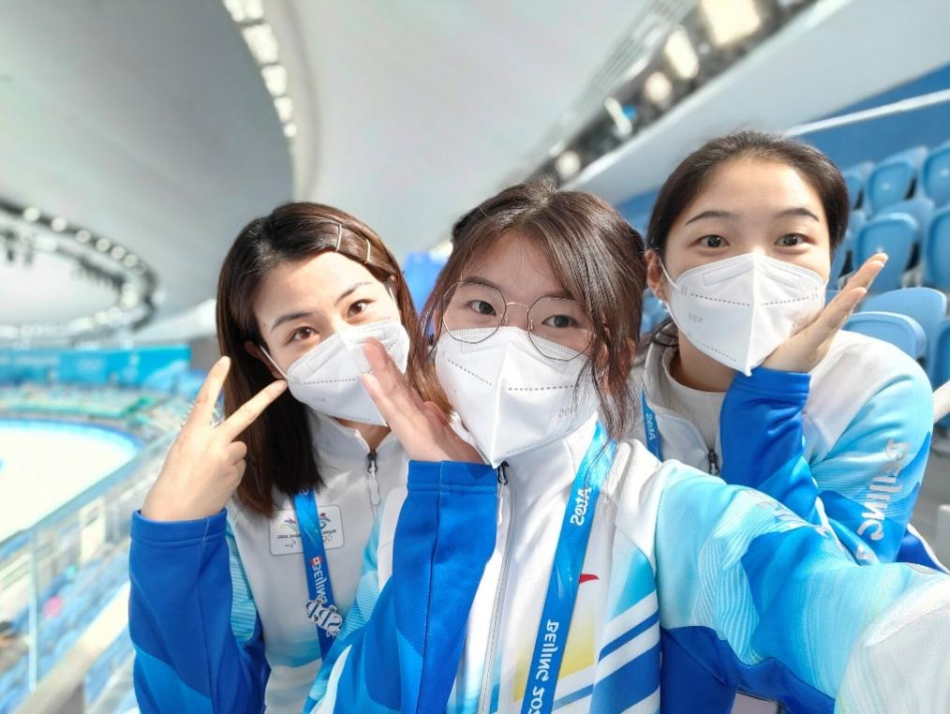
Volunteers at the National Speed Skating Oval

Wooden Blocks and Dolls Evoke the Innocence at Heart
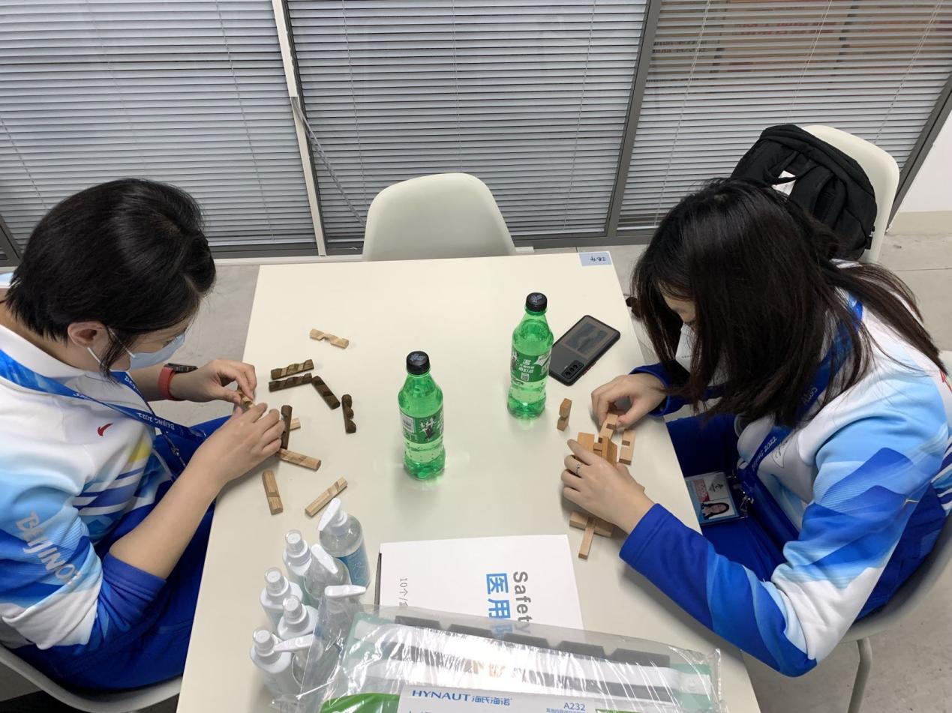
Putting Kongming Locks Together
Wang Xinyue’s Kongming Lock

Needle felting — “poke, trim and roll using a needle, a thread and a pad.” Transforming wool into dolls requires fine handwork as well as a sense of style.
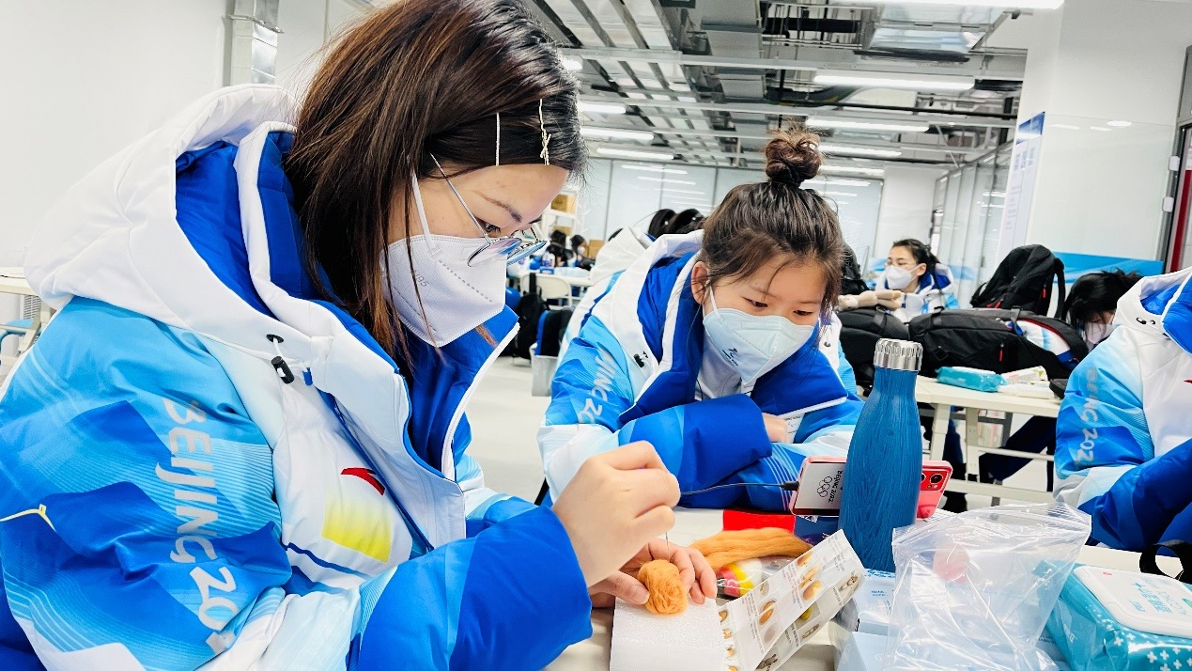
Fang Yuanyuan felting wool
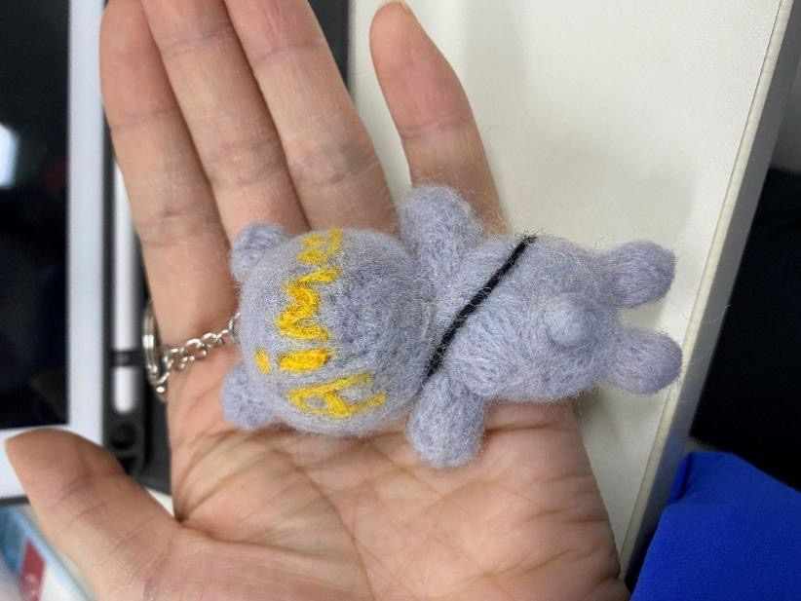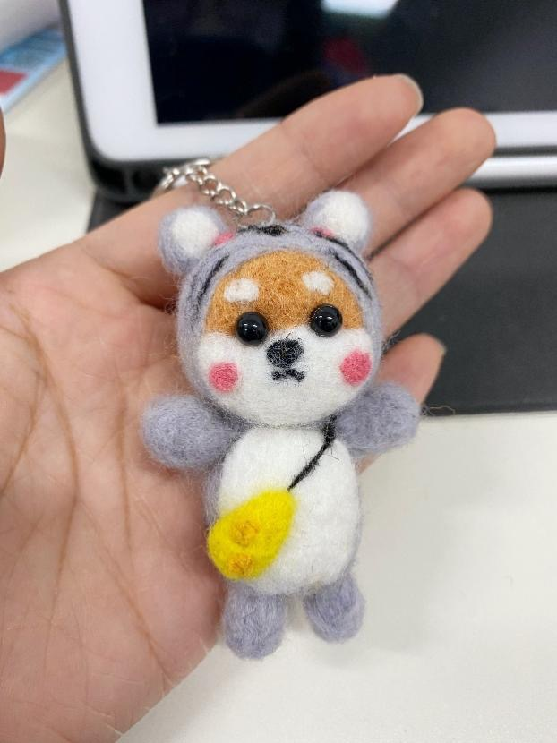
Finished wool felt doll

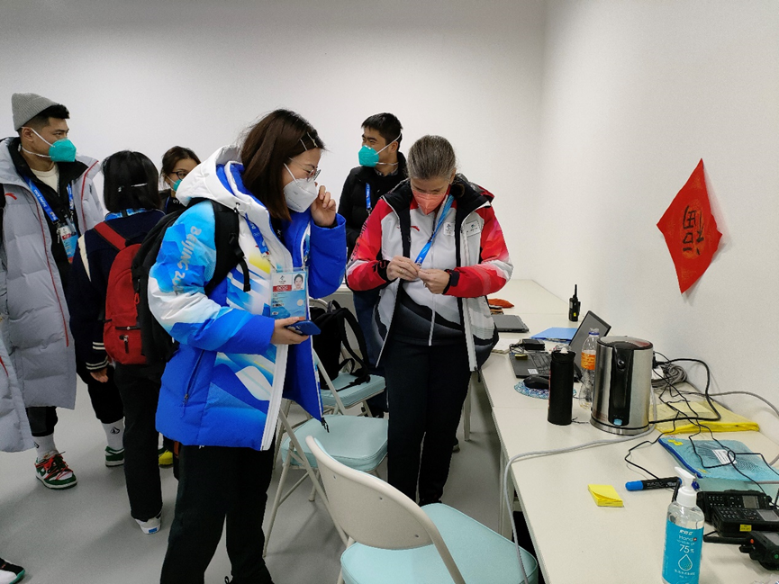
Fang Yuanyuan giving her handmade doll to her foreign teammate as a gift

Spring Festival Couplets and Home Letters Convey Deep Yearnings
On the evening of the Little New Year, couplets-writing activity was arranged. The smell of ink filled the air of the dining hall, where volunteers were writing Spring Festival couplets and character Fu (meaning good fortune) attentively. The Spring Festival couplets and character Fu carry the Chinese people’s aspirations to ward off evils and disasters, embrace happiness and good fortune, and their wish for a successful Beijing 2022 Winter Olympics.
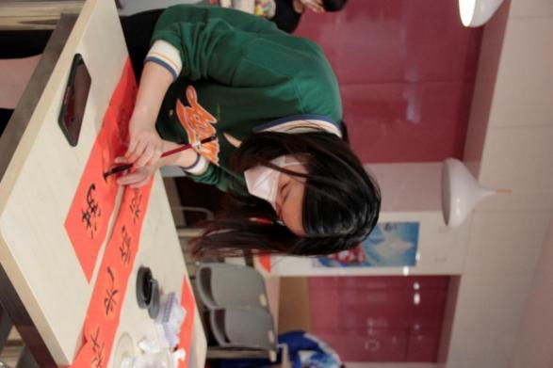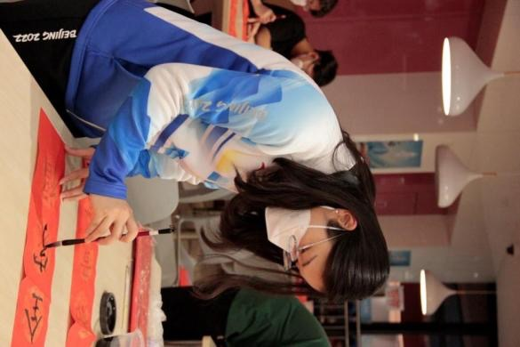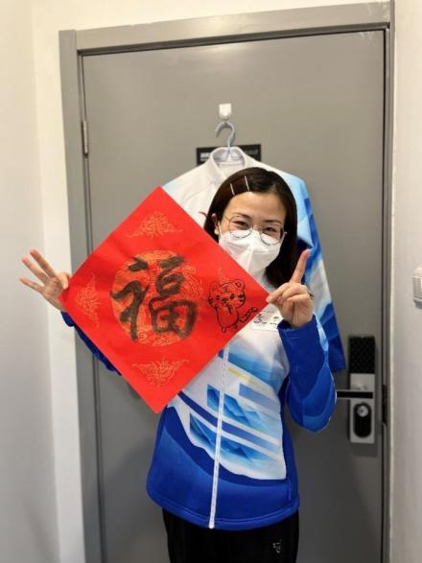
Wang Xinyue writing He Jingyang writing Fang Yuanyuan writing
Spring Festival couplets Spring Festival couplets character Fu

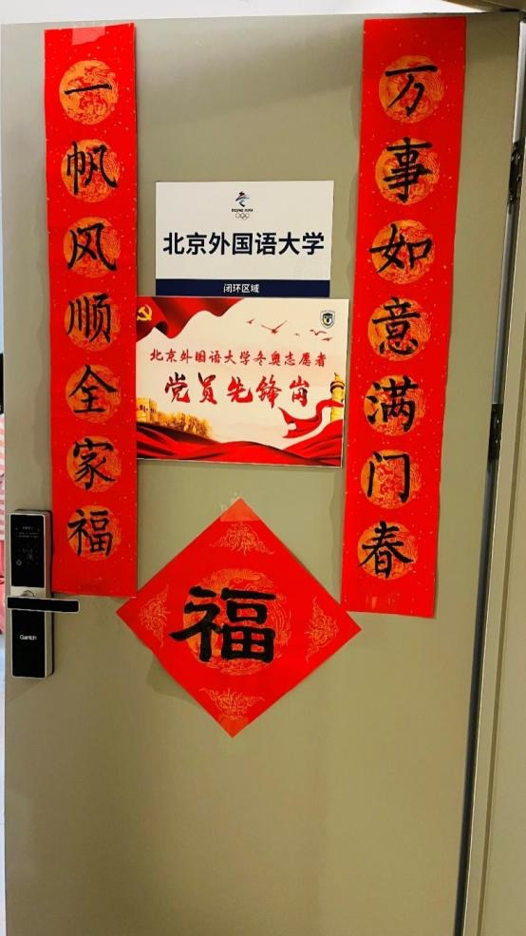
Spring Festival couplets pasted by He Jingyang on the dormitory door

“Home letter in a warm winter.” A home letter activity aroused the volunteers’ yearnings for home. Affectionate and in earnest, they wrote down their feelings in letters. Xu Yanhan, a 2020 postgraduate majored in English translation, wrote three pages to her family. Volunteers’ letters and photos were sent in envelopes to their families.
Home letters tell yearnings as well as stories. After their parents receive the letters, they will be relieved and feel proud of their children.
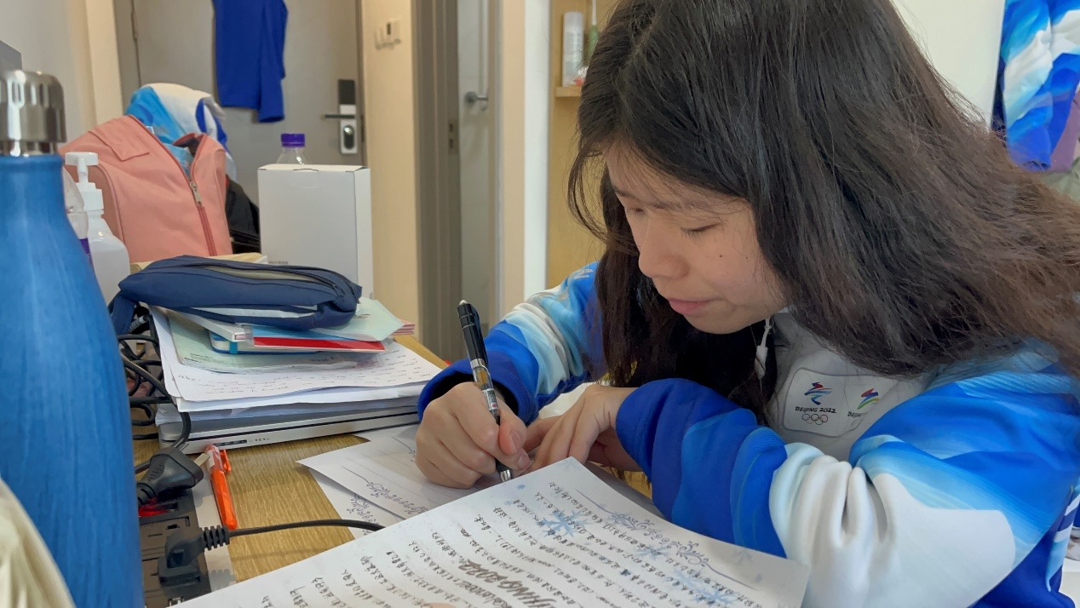
Xu Yanhan writing a home letter

Best Wishes through Handicrafts
Xu Yanhan wrote character Fu and explained the blessings it carries to her foreign teammates, who in turn expressed appreciation and anticipation for the Lunar New Year. They put paper-cuts on the walls and doors. The paper-cuts are of various shapes, such as snow, tigers, pandas, character Chun (spring), lanterns, roses and hearts. They filled the SPP Office with heartwarming aura of the Spring Festival, and added color to the National Speed Skating Oval.
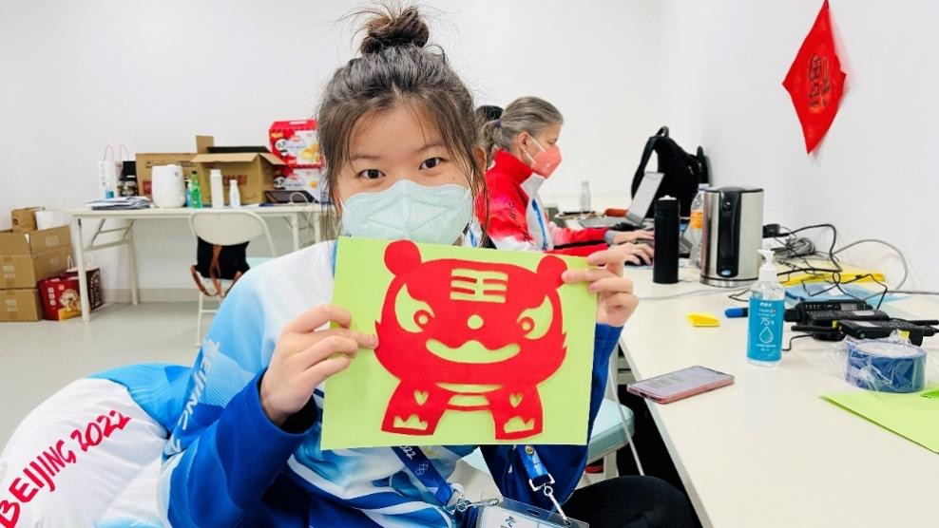
One of the paper-cuts made by volunteers

As one of the Chinese traditions, paper-cutting can light up festival atmosphere and bring the joy of beauty. BFSUers specialize in language services and Chinese culture is embedded in their hearts. Handicraft is a heritage. Language volunteers made handicrafts to illuminate the ambience of Chinese Lunar New Year, show the ingenuity of Chinese young people, express good wishes in foreign languages, and share Chinese customs and anecdotes of the Spring Festival.
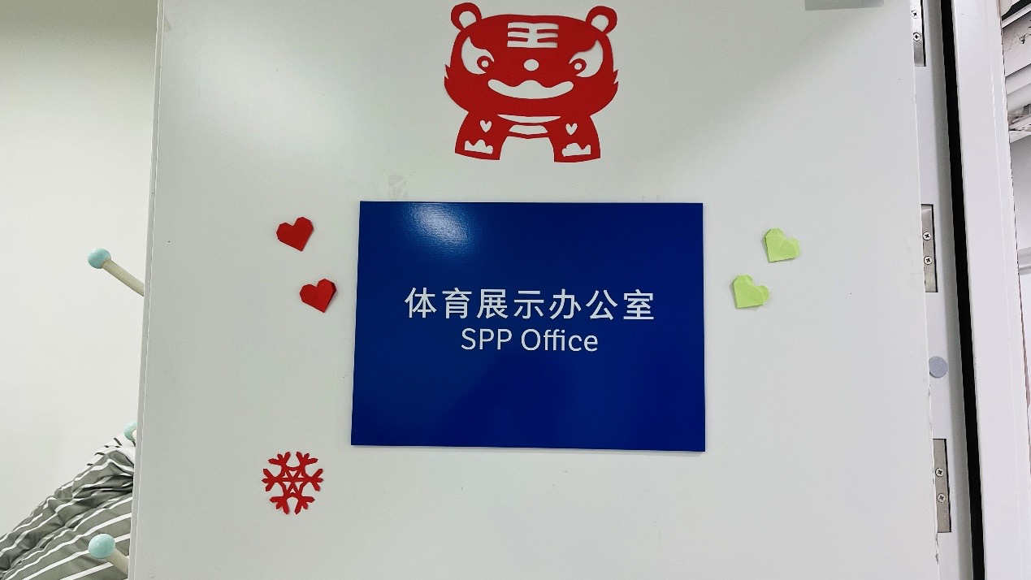
The SPP Office at National Speed Skating Oval decorated by volunteers

He Jingyang, Assistant of Sports Display and BFSU volunteer at National Speed Skating Oval, contributed to the story.

译者：李菁 朱悦 李文萱
指导老师：周明

